YouTube and Education: a great mix

Introduction
YouTube is a website which has thousands of short, topical videos. It is an excellent resource for teachers in every discipline. Finding and bookmarking quality and relevant videos can be difficult. This guide aims to help new users become acquainted with YouTube.
YouTube has some explicit content. Please search BEFORE a class and not during a class!!

HOWTO
Simply type a topic in the search box to see a wide range of videos.
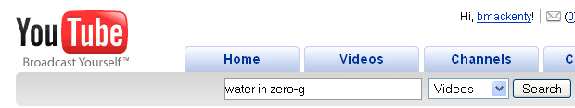

To watch a video, simply click on one of the videos.
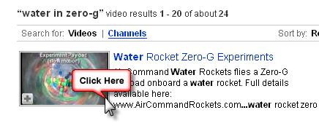

There are some controls on the bottom worth knowing about
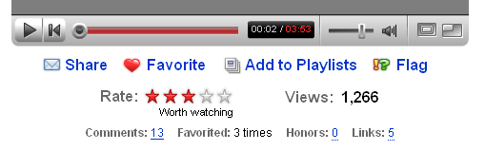
- These are normal play, pause, and restart buttons

- The red slider bar represents how much video has loaded. The ball represents the current place in the video. The white and red numbers represent the current time / total time. This is interesting because occasionally in the comment section of a video, someone will point out “at 2:45 you can see something interesting”.
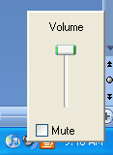
- There are the volume controls. If you can’t hear any sound you should check this volume control, as well as the volume control on your computer

- These control the video size. You can make a video full-screen. Push Escape to get back to normal video size.

If you want to save a video, you can bookmark it in your browser or…
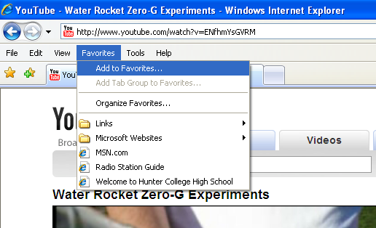

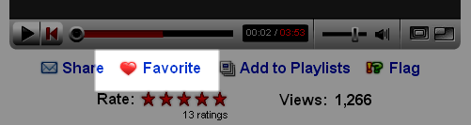
…you can sign into YouTube and click favorite…

You can also share a video. You must be logged in. Simply click share
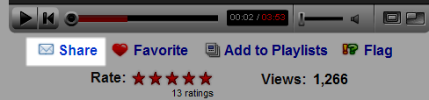

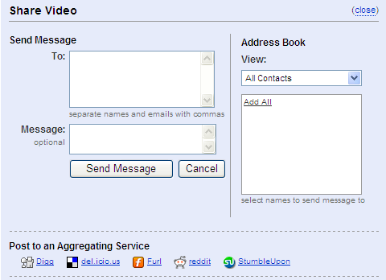
And then simply fill in the form which pops up.

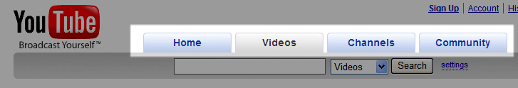
At the top of the page there are 4 tabs, Home, Videos, Channels and Community

The nice thing about the Videos tab is you can search within a list of categorized videos, see popular videos, and related videos. You can see some of the sub-searches here.
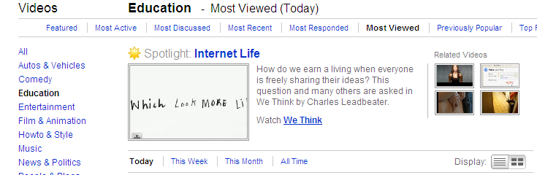

The channels tab focuses on individual users or groups who create a “presence” in YouTube. A person or group who has a channel might have several videos. For example, National Geographic has a channel.

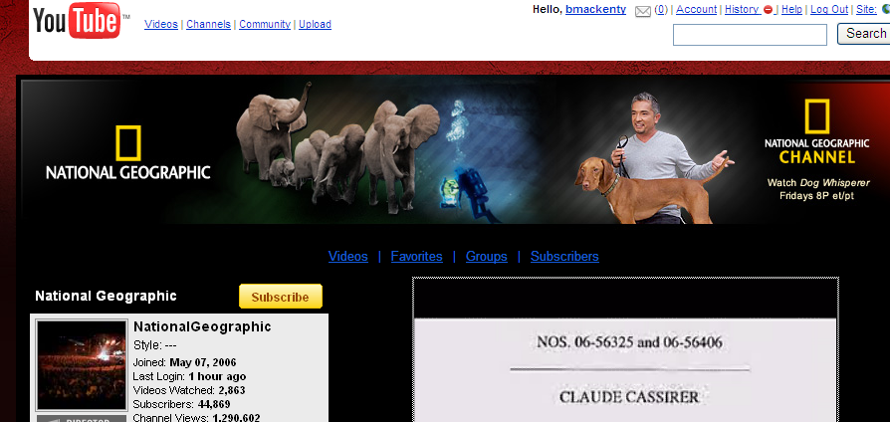

Many YouTube videos have comments. People can create a video response (which is literally a video response to the video) or a textual comment. These comments are quite helpful as people often point to innacuracies or provide depper level of information about a particular video.

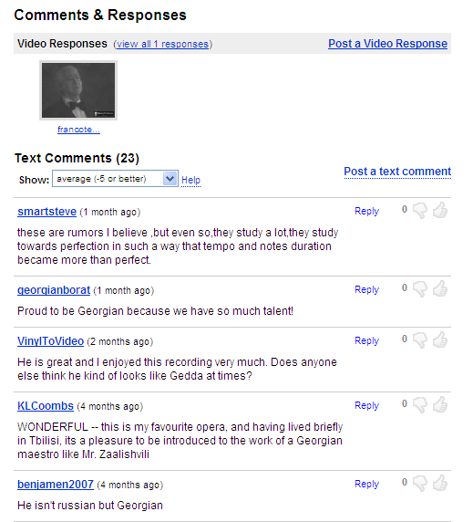

You tube is a great resource. I suggest browsing through the videos, so you get an idea what might be helpful for your classroom.

